|  |  |  |  |
| --- | --- | --- | --- |
| **SPMI** | **FORMULIR PROSEDUR AKADEMIK** | **No** | **0531/PL4.6.2/PK/2021** |
| **BAHAN RAPAT TINJAUAN MANAJEMEN** | **Revisi** | **1** |
| **Tanggal** | **7 Januari 2022** |
| **Halaman** | **1/1** |

**BAHAN RAPAT TINJAUAN MANAJEMEN**

|  |  |  |  |  |  |  |  |
| --- | --- | --- | --- | --- | --- | --- | --- |
| No | Jadwal TM | Unit Kerja | Auditor | Auditee | Laporan Temuan | Hasil Pemeriksaan | Status |

Semarang, 16 November 2022

Kepala PPMP

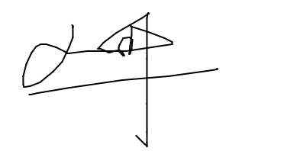

Pimpinan PPMP